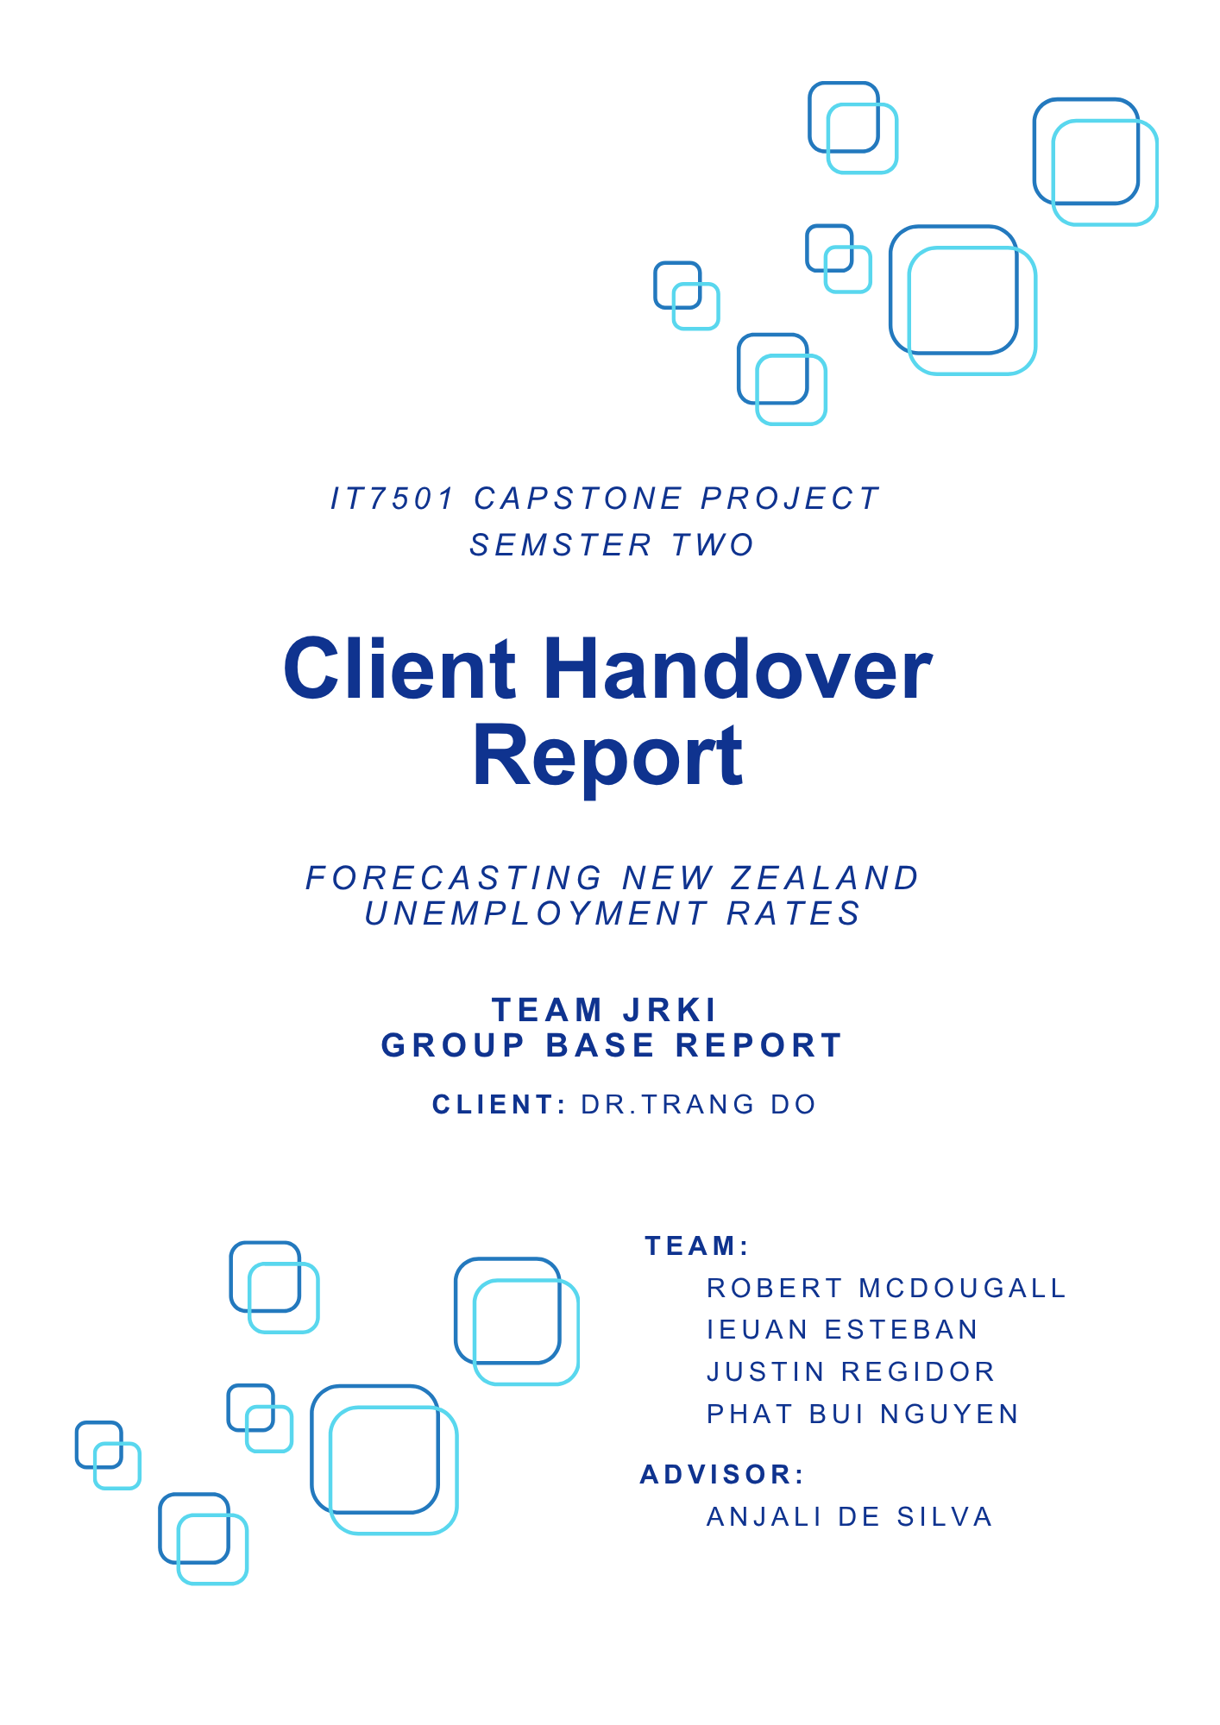

1.0 Table of Contents

1.0 Table of Contents 2
2.0 What the Project Is 3
3.0 Milestones Completed / State of the Main Deliverables 4
3.1 Completed Milestones Brief 5
3.1.1 Data Collection and Cleaning 5
3.1.2 Model Selected and Designed 6
3.1.3 First Dashboard Prototype 7
3.1.4 Dashboard Prototype 8
4.0 How the Project Will Be Maintained After Week 17 9
5.0 Key Technologies Involved 11
5.1 Programming Languages and Core Frameworks 11
5.1.1 Python 3.x 11
5.1.2 Power Query M Language 11
5.2 Machine Learning Models 12
5.2.1 Random Forest (Primary Model) 12
5.2.2 ARIMA/SARIMA (Comparative Model) 12
5.2.3 Gradient Boosting (Comparative Model) 12
5.3 Data Processing and Pipeline Technologies 13
5.3.1 Custom Python Pipeline Architecture 13
5.3.2 Anti-Leakage Framework 13
5.4 Visualization and Business Intelligence 14
5.4.1 Microsoft Power BI Desktop 14
5.4.2 Power BI Service (Planned Deployment) 14
5.5 Data Sources and Formats 15
5.5.1 Stats NZ Infoshare 15
5.5.2 CSV Format 15
5.6 Development and Collaboration Tools 16
5.6.1 Microsoft Project 16
5.6.2 Discord 16
5.6.3 Microsoft Teams 16
5.6.4 Zoom 16
5.6.5 Google Drive 16
5.7 Version Control and Documentation 16
5.7.1 Git/GitHub (Informal) 16
5.7.2 Microsoft Word 16
5.7.3 Markdown 16
5.8 Technical Architecture Summary 17

2.0 What the Project Is
The Capstone project called Unemployment Rate Forecasting is about forecasting New Zealand's unemployment rates through utilizing machine learning technologies and producing the results onto a Dashboard. The current problem with the unemployment rate (in general government measured datasets) is the time-lag between the actual dataset being released to the public and the ability to react to those changes with informed decisions by Government institutes or Business.
Our Client, Dr. Trang Do, has tasked us to create a machine learning forecasting system that can forecast StatNZ infoshare unemployment rates datasets and display those predictions into a Dashboard. This system needs to be robust to handle and produce accurate forecasting predictions from StatNZ datasets, that are updated periodically. While also maintaining readability for the Dashboard, in this case past the 5-second test.
This project is hoped to be used by other stakeholders such as the Ministry of Business Innovation and Employment (MBIE) or Business for decision making, as a way to address the time-lag problem of actual data being released.

3.0 Milestones Completed / State of the Main Deliverables
This section goes over all the completed Milestones presented to the Client that are completed and incompleted, and also the state of the main deliverables for each milestone at the end of Week 15. These milestones were originally proposed in the Project Proposal.

Table 3.0.1 - Completed Client Milestones
Requirement | Main Deliverables
Data collection/Cleaning | Pipeline
Model Selected and designed | Pipeline  Model: Random Forest
First prototype generated | PowerBI - Dashboard
Dashboard Prototype | PowerBI - Dashboard

Table 3.0.2 - Incompleted Client Milestones
Requirement | Main Deliverables | Status
Visualisation/Documentation | Justification Report  Instruction Manuals | Negotiate with Client to combine this Milestone with Report and visuals complete
Final PowerBI dashboard complete | Final Dashboard | Negotiate with Client
Report and visuals complete | Justification Report  Instruction Manuals | Negotiate with Client - Visualisation/Documentation

3.1 Completed Milestones Brief

3.1.1 Data Collection and Cleaning
This milestone was completed through the implementation of a Pipeline using python. The Pipeline processes the selected Raw Datasets from StatNZ info share website into Cleaned CSV files, ready to be trained by our Machine Learning Model.
Lists of Completed Deliverables:
• Selected StatNZ raw info share Datasets CSV files
• Household Labour Force (HLF) statistics by age, sex, ethnicity, and region
• Monthly Economic Indicators (MEI)
• Quarterly Employment Metrics (QEM)
• Consumer Price Index (CPI) and GDP data
• Electronic Card Transaction (ECT) statistics
• Cleaned StatNZ info share Datasets CSV files
• Household Labour Force (HLF) statistics by age, sex, ethnicity, and region
• Monthly Economic Indicators (MEI)
• Quarterly Employment Metrics (QEM)
• Consumer Price Index (CPI) and GDP data
• Electronic Card Transaction (ECT) statistics
• Pipeline: Preprocessing/Cleaning scripts
• JRKI_Forecasting_Pipeline.exe - GUI interface for the pipeline
• Simple_orchestrator.py - Pipeline controller script
• Comprehensive_data_cleaner.py - Cleaning script
• Demographic_unemployment_analyzer.py
• Temporal_data_splitter.py - anti-leakages script
• Time_series_aligner_simplified.py - anti-leakages script

Key Achievement:
Our pipeline is able to successfully clean and process all raw 29 StatNZ CSV files that are filled with missing data over 1914 to 2025. Created a standardised unemployment rate indicator across 198 demographic categories. The addition of our Anti-Leakages scripts ensures accuracy to the preprocessing of the data by stopping historical contamination within the raw datasets.

3.1.2 Model Selected and Designed
This milestone was completed through the implementation of a Pipeline using python. The final Pipeline utilizes our selected Random Forest model, from the 3 models we tested and evaluated.
Lists of Completed Deliverables:
• Implemented and compared three forecasting approaches:
• ARIMA/SARIMA: Time series models for capturing seasonal patterns
• Random Forest: Ensemble learning for non-linear pattern recognition
• Gradient Boosting: Advanced ensemble method for improved accuracy
• Pipeline: Preprocessing/Cleaning scripts
• Simple_orchestrator.py - Pipeline controller script
• JRKI_Forecasting_Pipeline.exe - GUI interface for the pipeline
• unemployment_model_trainer.py - Training script
• unemployment_forecaster_fixed.py - Forecasting script
• model_performance_dashboard.py - Model summary script
• Our Selection of our main chosen Model - Random Forest model
Key Achievement:
Our pipeline is able to successfully train and forecast our cleaned dataset. Evaluation of the model performance allowed us to pick Random Forest as our model for this project. We found that the best performing demographics achieved MAE below 0.5 percentage points, Age group 25-54 years showed most consistent forecasting performance across all regions and that Random Forest generally outperformed ARIMA for complex demographic intersections.

3.1.3 First Dashboard Prototype
This milestone was completed through the implementation of a first Dashboard that the Client could look over in week 13. This prototype contains a complete first-page with a skeleton of other pages based on a sitemap and mood board design.

Completed Deliverables:
• JRKI_Unemployment_Forecasting_Dashboard original.pbix - prototype to show to the client our completed first-page with interactive visualisation and slicers
• JRKI_Client_MM_13.docx - Our meeting with the Client in Week 13 and feedback
• W13_Client_Notes.png - Image of more notes on Client feedback in Week 13
• Stats_nz_powerbi_theme.json - json file containing colours and fonts for the dashboard

Key Achievement:
We were able to create an interactive prototype to show to the client, this prototype is a completed first-page with interactive visualisation and slicers. We were able to find what worked and what didn't in our brief meeting with the client. It honed our scope a little more for the Dashboard seeing which pages/visualisation is or not needed. This milestone gave us direction to complete a proper Dashboard Prototype ready for testing.

3.1.4 Dashboard Prototype
This milestone was completed through the implementation of a proper working Dashboard that was tested by our Team and Advisor. This Dashboard Prototype looks at all the demographics of unemployment rates, and a performance page. It was redesigned based on our Client feedback. This First Dashboard Prototype will be ready to be tested by our Client in Week 16.
Completed Deliverables:
• JRKI_Unemployment_Forecasting_Dashboard_Final.pbix - Dashboard prototype
• Functionality Testing Document.docx - Testing document
• Usability Testing Document.docx - Testing document
• User Acceptance Testing Document.docx - Testing document
• Testing Approach Documentation.docx - Testing document
Key Achievement:
We were able to properly test the Dashboard and document said test with proper documents. Our advisor was able to test it as well, improving our Testing of the Dashboard. Testing allowed us to refine the Dashboard by correcting a few minor bugs, ready for our client to test.

4.0 How the Project Will Be Maintained After Week 17
Maintenance Plan
The project will enter a maintenance and handover phase following Week 17, with a structured approach to ensure successful client adoption and system sustainability. The maintenance plan includes:
- Initial environment setup and configuration for the client's infrastructure
- Dashboard deployment and user access configuration
- Pipeline installation and testing in the client environment
- Documentation updates based on deployment experience
- Bug fixes and minor adjustments identified during client testing
- Knowledge transfer sessions with the client
Roles & Responsibilities
Justin and Robert will serve as the primary maintenance leads for the next two to three weeks following project completion. Their responsibilities include:
- Setting up the complete environment (Python dependencies, Power BI configuration, data connections)
- Installing and configuring the dashboard in the client's Power BI environment
- Deploying the pipeline system and ensuring proper functionality
- Providing technical support during the initial deployment phase
- Conducting training sessions for client users
- Responding to issues or questions that arise during early adoption

Client Testing & Validation

Dashboard testing with the client is potentially scheduled for Week 16 as part of the maintenance plan. This testing phase will include:
- User acceptance testing by Dr. Trang Do and stakeholders
- Validation of forecasting accuracy and dashboard functionality
- Collection of feedback for final adjustments
- Confirmation of system performance in real-world usage scenarios
Access & Permissions
Access arrangements will be established to support the maintenance period:
- Remote access credentials for troubleshooting and support
- Shared documentation repository for ongoing updates
- Communication channels (email, video conferencing) for support requests
- Temporary access to client systems for deployment and configuration
Reporting/Escalation Process
A clear process will be established for handling issues during the maintenance period:
- Minor issues and questions will be addressed directly by Justin and Robert
- Technical issues beyond the maintenance scope will be escalated to Dr. Trang Do
- Weekly status updates will be provided to the client during the maintenance period
- Documentation of all issues, resolutions, and system changes will be maintained

5.0 Key Technologies Involved
This project integrated multiple technologies across data processing, machine learning, and visualization to deliver a comprehensive unemployment forecasting solution. The technical stack was selected to balance analytical capability, ease of maintenance, and compatibility with potential government agency infrastructure.

5.1 Programming Languages and Core Frameworks

5.1.1 Python 3.x
Python served as the primary programming language for all data processing, cleaning, and machine learning components. Key Python libraries utilized include:
• Pandas: Data manipulation, cleaning, and transformation of the 29 raw StatNZ CSV files spanning 1914-2025
• NumPy: Numerical computations and array operations for efficient data processing
• Scikit-learn: Machine learning model implementation (Random Forest, Gradient Boosting) and evaluation metrics
• Statsmodels: ARIMA/SARIMA time series modeling and statistical analysis
• Matplotlib/Seaborn: Data visualization for exploratory analysis and model evaluation

5.1.2 Power Query M Language
Used within Power BI for data transformation, cleaning, and establishing relationships between forecast outputs and demographic metadata.

5.2 Machine Learning Models

5.2.1 Random Forest (Primary Model)
Selected as the primary forecasting model after comprehensive evaluation across 198 demographic indicators. Random Forest demonstrated superior performance for complex demographic intersections due to its:
• Ability to capture non-linear relationships in unemployment data
• Robustness to missing values (critical given 80%+ data suppression)
• Feature importance metrics for interpretability
• Ensemble approach reducing overfitting risk

5.2.2 ARIMA/SARIMA (Comparative Model)
Classical time series models evaluated for seasonal pattern detection and trend analysis. While effective for simple aggregated unemployment rates, ARIMA underperformed Random Forest for complex demographic breakdowns.

5.2.3 Gradient Boosting (Comparative Model)
Advanced ensemble method tested for potential accuracy improvements. Evaluated but not selected due to increased computational complexity without proportional performance gains over Random Forest.

5.3 Data Processing and Pipeline Technologies

5.3.1 Custom Python Pipeline Architecture
The project developed a modular pipeline system consisting of:
• JRKI_Forecasting_Pipeline.exe: Graphical user interface providing user-friendly access to pipeline functionality
• Simple_orchestrator.py: Central controller coordinating execution of all pipeline components
• Comprehensive_data_cleaner.py: Data preprocessing, missing value handling, and standardization
• Temporal_data_splitter.py: Anti-leakage temporal separation ensuring training/validation integrity
• Time_series_aligner_simplified.py: Time series alignment with anti-leakage protection
• unemployment_model_trainer.py: Model training across 176 demographic-specific forecasting models
• unemployment_forecaster_fixed.py: Forecast generation for specified time horizons

5.3.2 Anti-Leakage Framework
Custom-developed temporal isolation system preventing historical data contamination in forecasts. This critical component ensures:
• Strict temporal boundaries between training and validation datasets
• Prevention of "future peeking" during model training
• Reliable real-world forecast performance matching validation metrics

5.4 Visualization and Business Intelligence

5.4.1 Microsoft Power BI Desktop
Primary visualization platform selected for its:
• Widespread adoption in New Zealand government agencies
• Interactive filtering and drill-down capabilities
• Integration with Python outputs via CSV connectors
• Custom theme support (Stats NZ branding implemented via stats_nz_powerbi_theme.json)
Dashboard Features Implemented:
• Multi-page navigation structure
• Interactive slicers for demographic filtering (age, gender, ethnicity, region)
• Time range selection controls
• Forecast visualizations with confidence intervals
• Model performance metrics and evaluation pages
• Responsive design optimized for "five-second comprehension" standard

5.4.2 Power BI Service (Planned Deployment)
Cloud-based platform for dashboard sharing and automated data refresh capabilities, enabling live-updating forecasts for end users.

5.5 Data Sources and Formats

5.5.1 Stats NZ Infoshare
Primary data source providing official New Zealand economic and labour market statistics:
• Household Labour Force Survey (HLF): Quarterly unemployment rates by age, gender, ethnicity, and region
• Monthly Economic Indicators (MEI): High-frequency economic activity measures
• Quarterly Employment Metrics (QEM): Comprehensive employment statistics
• Consumer Price Index (CPI): Inflation indicators
• Gross Domestic Product (GDP): Macroeconomic context
• Electronic Card Transaction (ECT): Consumer spending patterns

5.5.2 CSV Format
All data inputs and outputs utilize comma-separated values format for:
• Universal compatibility across systems
• Ease of validation and manual inspection
• Efficient Power BI integration
• Archival and version control simplicity

5.6 Development and Collaboration Tools

5.6.1 Microsoft Project
Initial planning tool for Gantt chart development and milestone scheduling (though later underutilized as discussed in Section 5.3).

5.6.2 Discord
Primary communication platform for team collaboration, daily standups, and informal progress updates.

5.6.3 Microsoft Teams
Video conferencing platform for weekly advisor meetings and formal project reviews.

5.6.4 Zoom
Video conferencing platform for biweekly client meetings with Dr. Trang Do.

5.6.5 Google Drive
Cloud storage for shared documentation, meeting notes, code versioning, and collaborative file editing.

5.7 Version Control and Documentation

5.7.1 Git/GitHub (Informal)
Used informally for code versioning and backup, though not as rigorously as enterprise standards due to team experience level.

5.7.2 Microsoft Word
Documentation platform for academic deliverables, testing documents, and handover materials.

5.7.3 Markdown
Lightweight documentation format for README files and technical specifications within the codebase.

5.8 Technical Architecture Summary
The overall system architecture follows a three-tier structure:
• Data Layer: Raw CSV files from Stats NZ → Python preprocessing pipeline → Cleaned datasets
• Model Layer: Feature engineering → Model training (Random Forest) → Forecast generation → Performance evaluation
• Presentation Layer: CSV exports → Power BI ingestion → Interactive dashboard → End user consumption
This architecture ensures separation of concerns, maintainability, and the ability to update models or visualization independently as requirements evolve.

